PMMA - Reactor Unit

Purab Gupta (2022chb1055)

Aditya Vikram Sharma (2022chb1038)

Dr. Jayram Valluru

27 March 2024

1. **Process / System Details**

**Outline -** For this study, a free-radical MMA polymerization method was employed. Azo-bis-isobutyronitrile (AIBN) is used as an initiator and toluene as a solvent during polymerization in a CSTR.

**Mechanism -**The free radical reaction mechanism of MMA polymerisation includes the following

1. Initiation
2. Propagation
3. Monomer Transfer
4. Addition termination
5. Disproportionation Termination

**Assumptions-** The following presumptions serve as the foundation for developing a mathematical model of the process: The reactor must have the following characteristics: (a) a constant volume; (b) completely mixed contents; (c) no gel effect; (d) uniform cooling fluid temperature; and (e) constant heat capacity and density of the cooling fluid and reactor mixture.

**Theory** - Non- linear estimation methods studied serve as a base for creation of the mathematical model made to achieve desired target from the given sample inputs (which are discussed in the second part of report ) . The methods are as follows:

1. Extended Kalman Filter (EKF)
2. Unscented Kalman Filter (UKF)
3. Particle Filter (PF)

The model is evaluated under several conditions, including plant-model mismatch, Gaussian and non-Gaussian state and measurement noise sequences. By utilizing these case studies, we determine the conditions under which a notable variation in filter performance is demonstrated.

|  |  |  |  |  |
| --- | --- | --- | --- | --- |
| **Case** | **Measurement**  **Noise** | **State Noise** | **Plant-Model**  **Mismatch** | **Choice of Filter** |
| 1 | G | - | - | EKF, UKF, PF |
| 2 | G | G | - | UKF,PF |
| 3 | NG | NG | - | UKF,PF |
| 4 | NG | - | - | EKF UKF, PF |
| 5 | NG | - | In parameter | UKF, PF |
| 6 | NG | - | Parameter Estimated | UKF,PF |

1. **Dimensionality of Problem**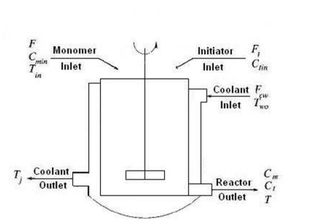

There are 7 input variables and 1 output variable

**Input_1** = Initiator Concentration(CI)

**Input_2** = Temperature (T)

**Input_3** = Jacket Temperature (T)

**Input_4** = Coolant water flow rate (Fcw) **MMA Polymerisation reaction flow sheet**

**Input_5** = Monomer inlet Flowrate (F)

**Input_6** = Coolant inlet temp.water (Two)

**Input_7** = Inlet temperature of Feed (Tin)

**Output_1** = Monomer Concentration

1. **Aim/Objective**

The aim of this project is to develop a predictive model for accurately forecasting the monomer concentration in the Poly-Methyl Methacrylate (PMMA) Reactor Unit.

**The proposed objective can improve the operation and economy of the process by following :**

* **Improving process control** by accurately predicting the monomer concentration , allowing operators to make timely adjustments
* **Reducing production Costs** by optimizing raw material usage and energy consumption
* **Enhancing product quality** by maintaining the desired monomer concentration levels